

Workforce Planning Strategy

2023-2026

**January 2023**

Contents

1. BACKGROUND AND INTRODUCTION 3

1.1 Background and summary 3

1.2 Current workforce profile 3

1.2.1 Age 3

1.2.2 Working patterns and contract type 4

1.2.3 Gender 4

1.2.4 Staff location 4

1.2.5 Absence 4

1.2.6 Professional Roles 4

1.3 Current Workforce within Service Delivery Model 4

1.4 Current workforce challenges 5

1.5 Strategy for dealing with the workforce challenges 5

1.6 The role of professional bodies 7

1.7 Apprentices 8

2. SKILLS DEVELOPMENT 8

2.1 Staff groupings 8

3. THE WORKFORCE SYSTEM 9

4. SKILLS RESILIENCE (Learning and Development) 9

4.1 Core Skills 10

4.2 Management and Leadership Skills 10

4.3 Technical Skills 10

4.4 Service Development Skills 10

5. UNDERSTANDING SERVICE CAPACITY 11

5.1 Managers 11

5.2 Professional 11

5.3 Support 11

5.4 Subject Matter Experts 11

5.5 Generalist 11

5.6 Cross cutting 12

A. Workforce Profiles 13

Entry Point for Roles 13

Exit Point for Roles 14

# BACKGROUND AND INTRODUCTION

## Background and summary

PPP employs around 80 permanent officers across a variety of professional and technical support roles and 12 casual and/or Agency staff. It operates a number of contracts on behalf of other services and has a business plan which seeks further growth.

The changing demands and fluctuating priorities faced by services such as PPP require considered, careful and measured ways of managing the important resource of its workforce.

The Public Protection Partnership (**PPP**) consists of three local government regulatory roles:

1. Trading Standards,
2. Environmental Health, and
3. Licensing.

These roles are professionally based, broad in remit and ultimately open to legal challenge if not carried out correctly.

There are also a significant number of roles which are in place to support the professional officers for example ensuring the customer interface is maintained and quality of data and information.

|  |
| --- |
| The PPP Workforce Aim |
| To have a workforce which is qualified, experienced and well trained and fit for purpose. |

We recognise the benefit of workforce planning as a method of keeping disruption to a minimum and aim for a dynamic and skilled workforce able to use core skills to minimise issues presented by workforce changes and exterior pressures.

The complexities of the service and the way in which it is delivered mean that the certainty and ability of detailed future planning of the workforce is harder than in some industries, however we will plan generically and aim to build in flexibility wherever possible.

This strategy (and associated documents) draws upon published material from a range of organisations[1] and should provide a solid platform for future decisions about investing in recruitment, skills and abilities which best place the service to deliver against its aims.

## Current workforce profile

### Age

The service has split of age ranges with some apprentice/school leaver roles through to a number of staff at or near retirement age. In particular of the currently filled posts around 13% are already on flexible retirement arrangements, reached retirement age or are able to take retirement within the next 3 years.

### Working patterns and contract type

As of January 2023, the majority of employees are on permanent full time contracts, and there are minimal numbers of casual and/or agency employed at any given time. The total FTE across the service equates to 68.25.

Agency staff are employed on a case by case basis and with current rules the service carries out assessment of these for compliance with IR35 requirements.

### Gender

Total workforce identifying as Male is 30% (24) and Female is currently 70% (56). This is a change from the proportion in 2020 of 25% and 75% respectively.

### Staff location

The service is split across 3 locations with new staff being appointed to the central Theale office. For those appointed prior to this office opening (Sept 2017) the split was Newbury 44%, Wokingham 26%, Bracknell 17% and Theale 14%. Theale now dominates in terms of staff base as all new appointments in recent years have been to the Theale base. However, since the changes in the Wokingham partnership in 2022, all previously Wokingham based staff have relocated to alternative offices across Theale and Bracknell Forest mostly. There are a few trading standard officers who are still able to operate out of Wokingham for practical purposes.

### Absence

The size of the PPP means that it is likely that from time to time there will be staff experiencing extended periods of absence from work. The levels experienced within service in the last 3 years is below average.

### Professional Roles

The recognised professional roles are:

* Lawyers/Solicitors
* Trading Standards Officers
* Environmental Health Officers
* Licensing Officers

There are 29 officers who are accredited as qualified officers, each requiring between 20-30 hours of Continuing Professional Development. In addition there are a number of Accredited Financial Investigators and Senior Authorised Officers (for Proceeds of Crime) which are professionally recognised roles.

## Current Workforce within Service Delivery Model

The PPP is a new way of delivering regulatory services at local authority level. Most councils across the country operate at either city/borough, unitary or county level which means the services are on a far smaller scale or split amongst different providers. By combining them at this level we are able to deliver a ‘best value’ service which will provide our stakeholders a cheaper, better quality and more comprehensive package.

We aim to avoid potential drawbacks of this service model by ensuring our workforce remain competent within their own professional fields at the same time as broadening their abilities to deliver in other areas. They can then provide resilience in the other fields as well as having a useful awareness of the range of activities performed by those services.

The PPP has a range of different provider roles which will affect its workforce planning;

* **Direct service provider** – directly delivering the Regulatory Services functions within the 3 council areas. The workforce will be effected by budget cuts, political changes of priority etc.
* **External service provider** – contracting with other services and councils to deliver on their behalf.
* **Technical Specialist Contractors** – we currently have a number of specialist contracts services such as Animal Health Inspections, out of hours stray dog collection and management of air quality monitoring units.

PPP recognises the benefit of building in workforce resilience to interior changes and exterior pressures and addresses this in a number of ways including:

* Preserving budget to pay for temporary staff when necessary. E.g. during times of legislative change, emergency issues (e.g. Foot and Mouth outbreak) or lengthy national investigations.
* Having budget to pay staff overtime where necessary to ensure delivery of Service commitments, e.g. attendance at large events such as music festivals, or inspections of food operators.
* Upskilling staff and maintaining a number of generalist staff who can undertake a broad spectrum of tasks.
* Consistent re-evaluation of workflow and resources through our tasking system (weekly meetings to address workloads and pressures upon the service).

## Current workforce challenges

**The main challenges that are currently faced by the service workforce include:**

* Financial uncertainties
* Political uncertainties
* Workforce profile and approaches
* Attracting new (professional) members of staff
* Developing professional officer roles
* Clarification of roles and responsibilities across a shared service

## Strategy for dealing with the workforce challenges

|  |
| --- |
| Structural uncertainties - The service is continually evolving, with uncertainty on which teams, professions or officers will be undertaking particular tasks now and in the future, and therefore the level of ‘manpower’ required in those areas. |
| The PPP will work to maintain records of staff, their training to understand the resourcing available at any one point. The use of Strategic Tasking to guide resourcing of teams and priority work areas will give clarity in decision making for all. There is also a need to recognise certain activities may require a specialist officer and that it is acceptable to “buy in” the skill for the short term. |
| Historic issues – For some there remains a ‘silo’ professional approach and out of date ideas of service delivery, this makes results in less fluent workforce planning. |
| The PPP will ensure the structure, which embeds the national intelligence model, has a clear workflow and through Strategic and Tactical tasking we focus resources and appropriate skills to priority work. Training should be in line with the service needs supported by the individual training and development plans stemming from their appraisals. Maintaining a broad skill base across the service will enable officers to work in any team with the appropriate management support. |
| Political uncertainties – There remains uncertainty concerning legislative and economic uncertainties and changes. Local political uncertainties can affect the shaping of the service and include financial constraints. |
| Through the Strategic and Tactical tasking processes the service will ensure that horizon scanning and local/national issues are considered within priority setting. Changes in legislation will be reviewed and staffing impacts and training needs assessed. The service is open to “buying in” technical specialists for short term projects or investigations but it will always be reviewed against the benefits of supporting internal staff to develop new skills. Linking into internal management and strategy groups will ensure our work is aligned with the Council Plans for each authority. |
| Workforce demographic – The recruitment of new staff within enforcement roles has attracted more experienced officers, with a number of field officers having possibly already retired from another service (e.g. Police). The workforce is therefore at risk whereby officers decide move towards reducing hours to balance work and retirement choices and/or leaving within a short space of time from recruitment. Staff may also leave if there are more opportunities for career development away from the service. |
| The PPP will develop clear career development paths to ensure new staff into the service are certain of the opportunities to develop and learn from those more experienced staff. The use of mentoring and coaching from those staff who may be near retirement is essential to minimising the risk and improving resilience should those officers move on. We will develop an apprentice scheme with the aim of bringing younger staff into the workforce and “growing our own” in hard to recruit to posts. |
| Workforce demographic – Whilst bringing in valuable knowledge & experience, having an aging and/or stagnated workforce can have negative affect. For example, officers may no longer reflect general society and can be stuck in dated working methodology and ideals. |
| The PPP will ensure we have a workforce who are able to deliver the needs of our communities regardless of the age of the workforce. As a service we need to recognise this issue and ensure we have good information sharing, training and an understanding of our customer needs to manage this. We can gain support from the internal services in each authority to ensure our services are designed for interacting with all sectors of our population using technology to our advantage in delivering this. We also need to support change in a fast moving and ever changing environment. |
| Attracting new members of staff – Current recruitment has identified that attracting new staff to the service in the professional fields of Environmental Health and Trading Standards has proved difficult. Factors such as the competiveness of salaries, location (size of area) and current market availability of qualified professionals. This is something recognised by West Berkshire Council and not unique to the PPP. |
| The PPP will work with the Joint Management Board members and the support services (HR) within the authorities to review the current arrangements and ensure that the uniqueness of the service is recognised. The culture of “growing your own” is already in place with a number of staff having been supported through gaining qualifications within the PPP and a number of apprentice roles in place. As a service we possess a clear career progression path so staff can see the potential opportunities for development. |
| Internal issues within the service – There remains a need to understand better roles and legacy issues around pay (related to TUPE arrangements). |
| The PPP needs clear identification of roles and responsibility with clarity and consistency needed on Job Descriptions across the service. The service requires one set of JD’s for each role and a review of the job titles to ensure officers and managers are clear on expectations and requirements of their roles. |

## The role of professional bodies

The professions within PPP all have their own professional bodies as listed below.

|  |  |
| --- | --- |
| Professions | Organisations |
| Environmental Health | **The Chartered Institute of Environmental Health** (CIEH)  <https://www.cieh.org/> |
| Case Management | **The Law Society**  <https://www.lawsociety.org.uk/> |
| Licensing | **The Institute of Licensing** (IoL)  <https://www.instituteoflicensing.org/> |
| Trading Standards | **The Chartered Trading Standards Institute** (CTSI) (and local Southern Branch)  <https://www.tradingstandards.uk/>  **The National Trading Standards** (NTS)  <https://www.nationaltradingstandards.uk/>  **Trading Standards South East** (TSSE)  <https://www.tsse.org.uk/> |

The role of these bodies vary but generally they champion, lobby, assist, organise and promote the work of the professions.

In order for PPP to operate to potential, the support and training offered by these (and other) organisations is maximised to ensure our workforce remains’ competent and that the service remains relevant. To this end, most staff receive regular updates from the bodies and should act upon any ‘action points’ accordingly. The IoL and TSSE are particularly active in promoting training courses and legal updates covering the full range of tasks undertaken by the service.

By using the support of the bodies we ensure,

* Our professional and ‘generalist’ workforce maintain their competency,
* Lead officers continue to keep their high level of expected expertise,
* We benefit from the ‘horizon scanning’ from other organisations across the country which can enable us to restructure or revise ourselves early.

## Apprentices

The PPP (through West Berkshire Council - the “Employer”) are signed up to the recruitment through the National Apprenticeship Scheme.

PPP have made use of these funds to help with the training of new field officers by using one of the approved courses. In particular, 4 Regulatory Compliance Officer Level 4 roles, and is in place to deliver a number of professional and specialist roles at Level 6 during 2023, including 2 environmental health officers, and 2 trading standards officers.

This training takes between 18 months (L4) & 4 years (L6) and has an end of course assessment once completed. The training is not stand alone but undertaken whilst performing basic normal work tasks within the service under the control of more experienced officers.

It is anticipated this training will assist in creating new officers to the professions by giving them foundation level skill and knowledge allowing them to develop further within the regulatory field. These officers can then remain as Regulatory Services staff with the intention of assisting with lower level work across the 3 services or they can use it as a step in progression towards training as a fully qualified officers within one of the professions and undertaking higher level work.

The Scheme only pays for the training of the officer, so the service must pay for the officer’s salary. If the training and support offered by the scheme proves beneficial and valuable it is hoped that salaries may be found to pay for these posts (possibly from those older officers who retire).

The two main advantages of the apprenticeship scheme should be the ability to grow our own officers to the needs of the service as well as the encouragement for experienced officers to act as mentor’s and develop in this area too.

# SKILLS DEVELOPMENT

## Staff groupings

Staffing within the service can be defined at a number of levels and may relate to technical knowledge and competency, specific skill sets (finance) or management responsibilities:

* ***‘Trainees/Apprentices’***

E.g. Trainee Regulatory Services Officer

* ***‘Operational Support’***

E.g. Applications, Customer Care and Finance officers.

* ***‘Generalists’***

E.g. Trading Standards Fair Trading Officers, Environmental Control or Licensing Technical Officers who undertake a broad spectrum of tasks

* ***‘Professional’***

E.g. Trading Standards, Environmental Health or Licensing Officers with more qualifications.

* ‘***Subject Matter Experts’***

E.g. Lead Officers for Contaminated Land, Food legislation or Financial Investigators

* **‘Cross Cutting’**

E.g. Intelligence officers, disclosure officers

* ***‘Managers’***

E.g. Principal, Strategic etc.

These roles (including Entry and Exit points) are outlined in more detail in APPENDIX A.

# THE WORKFORCE SYSTEM[2]

The diagram below shows the stages and general route through the workforce system within PPP.

Wastage can occur between each stage through promotion to other posts, resignation, retirement or other reason.

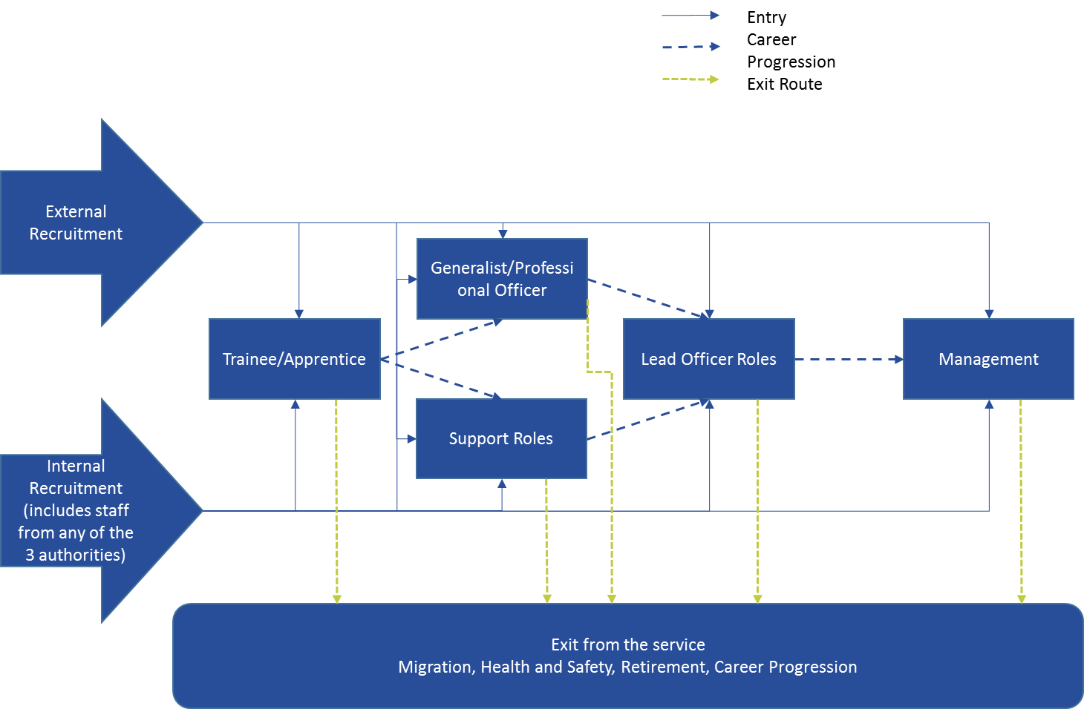

# SKILLS RESILIENCE (Learning and Development)

We recognise within the Training and Development Plan that there are key areas to focus on within the service. Whilst Professional Competence and Personal Development are important to overall service delivery we have to recognise that improving our communication with the customer, quality statement writing and other core skills are key as the other areas will fall down if the basics are not right.

## Core Skills

* Communication
* Problem solving
* Investigation techniques
* Interviewing under caution
* Handling complaints
* Managing expectations
* Understanding the PPP operating model

## Management and Leadership Skills

* Managing change
* Performance management
* Project management
* Budget control
* Analysing intelligence products

## Technical Skills

* Conducting financial investigation
* Conducting profession/sector specific enforcement
* Handling communications data

## Service Development Skills

* Service promotion
* I.T. and service delivery

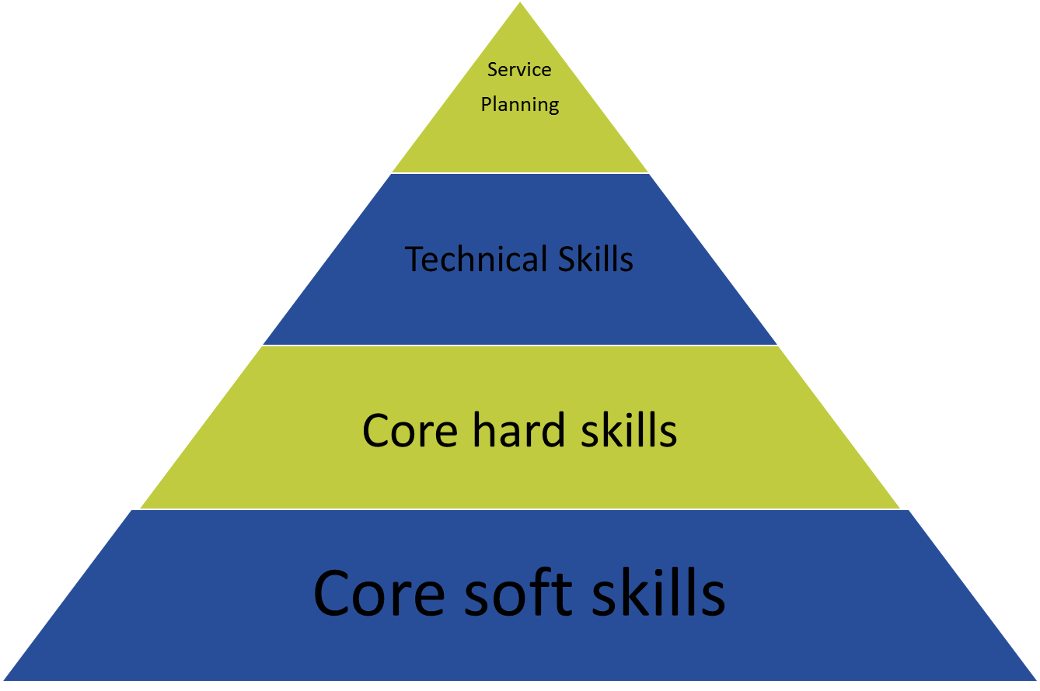

APPENDIX D sets out the summary of the Draft Learning and Development plan. This is a live document as it needs to reflect the management of external and internal factors which are

constantly evolving.

# UNDERSTANDING SERVICE CAPACITY

|  |  |  |
| --- | --- | --- |
| **Functional Area** | **Employed FTE** | **Vacant FTE** |
| **Licensing** | 5.53 | 5.88 |
| **Environmental Health** | 29.53 | 2.38 |
| **Trading Standards** | 12.49 | 2.87 |
| **Intelligence Unit** | 1.5 | 0.0 |
| **Case Management** | 3.86 | 1.0 |
| **Partnership Support** | 5.84 | 1.0 |
| **Investigations** | 2.0 | 2.0 |
| **Financial Investigations** | 2.0 | 0.0 |
| **Governance, Policy and Systems** | 2.5 | 1.0 |
| **Trainees** | 3.0 | 1.0 |
| **Total** | 68.25 | 17.13 |

## Managers

The Management Team comprises of 1 Service Manager, 3 Strategic Managers, & 8 Principal Officers and Partnership Support Manager. There are other managers within the system however they are senior officers within one of the other roles.

## Professional

Whilst the service retains a number of professional officers there has been an issue with recruitment and a number of part time workers shows a significant difference. All managers listed above are also Professional Officers who are no longer involved in day to day support.

## Support

Support staff can be considered as all non-operational staff. This includes customer delivery, governance, case management and Intel functions. There are also support officers within the licensing team who process and advice on licensing applications.

## Subject Matter Experts

Historically these have been the more technical specialist roles. As a service we have not appointed too many of these roles for some time. The most recent being to an Enforcement Officer (Animal Health) which is a specific role which requires specialist knowledge of a discrete area of work. This is often an area where we have lacked resilience and requires careful workforce planning.

## Generalist

This role encompasses a majority of operational enforcement roles, ranging from discreet responsibilities, such as fly-tipping enforcement to general enforcement in all matters linked to licensing enforcement, trading standards and environmental health.

## Cross cutting

These roles have developed as a theme to promote cross cutting issues across PPP. There are a number of roles in their existing format which naturally cross cut the service such as Victim Support Officer but there are also more niche roles which are currently a “bolt on” to existing day to day operational work such as Safeguarding Lead and Training Lead. Cross cutting roles would also include community public health officer functions, such as the support with confidence scheme management, smoking cessation and alcohol reduction.

## Workforce Profiles

## Entry Point for Roles

**Operational Support**

The entry point for most PPP operational support staff is external recruitment. These staff may already be experienced in this type of work or as the service continues to encourage apprenticeships we hope to train apprentices who can then become permanent staff.

Such is the expansion of the service, that this has created a need for Technical Leads within this group of staff.

**Regulatory Service Officer**

The introduction of RSO’s is a positive addition to the service in its future planning. Level 4 trained staff will have a level of knowledge (and experience) which would enable them to ‘hit the ground running’ in most aspects of regulatory controls throughout the service. Knowledge and skills will develop through mentorships, senior officer support and shared learning will continue grow as subsequent cohort join.

The service will create a ‘bank’ of RSOs who are qualified to level 4 Compliance, who in-turn will be guided into professional roles to fill the expected vacancy appears.

The service will maintain that;

1. Professional officers will be as comprehensively and broadly qualified as possible – to give the flexibility to rotate between teams & deliver different aspects of service depending on service need.
2. RSO’s will be provided with a career pathway that will enable them to remain in their current role or to become qualified officers in one of the professions.
3. Training and opportunities to develop will be fairly offered and balanced with service needs and sustainable.

**Professional Generalist**

The operating model for PPP demands high quality professionals capable of acting in a multi-disciplinary way. There are distinct skills required of staff that operate in this capacity and normal entry to this grouping would be as a trainee.

Currently the group is made up of staff with professional qualifications or demonstrate expertise in problem solving and communication. The level of independence and delegated authority allowed is directly proportionate to qualification, skills and experience.

Most staff will be affiliated or registered with a professional body and be able to demonstrate a track record of CPD (Continual Professional Development).

**Technical Specialist**

Working alongside the *Professional Generalist*, the nature and complexity of PPP workloads requires some staff to enhance their knowledge in specific areas.

These areas will be determined by the current strategic priorities and entry to this grouping is likely to be internal development of trainees.

Currently the group is made up of staff with professional affiliations who have significant experience in a particular function. There will be demonstrable CPD in these areas of specialism throughout the group.

**Managers**

The current management structure demonstrates a mix of backgrounds. Requirements at this level tend to be around recognised management qualifications and experience of managing staff. Future entry will be focussed on internal development of senior professional and operational support staff.

# Exit Point for Roles

**Operational Support**

In recent years some staff that have left this group to become trainees and move into the Professional Generalist or Technical Specialist group. There has been some natural wastage but no identifiable trends.

**Professional Generalist and Technical Specialist**

These two groups suffer from natural wastage in the main and within the next 10 years or so, a significant proportion will reach retirement age. Succession planning is key and we seek to address this by actively taking on younger staff where possible and to ensure we have collaborative working between the older more experienced staff and the less experienced ones to ensure that experience is not lost when those older ones go.

**Managers**

The creation of PPP and subsequent reorganisations have resulted in changes at management level. Natural wastage is the most common staff loss in this group apart from a few recent redundancies. Recent examples indicate that people leave for promotions, relocation of family and changes in work patterns as a result of shared services.

1. Health Education England (2016/17), NHS Education for Scotland (2016/17), Institute for Employment Studies (2008)
2. Workforce planning guide – Institute for Employment Studies (2008)