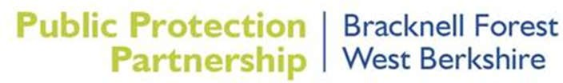

Reducing the Harms Caused by the Illegal Sale of Age Restricted Products Policy Statement

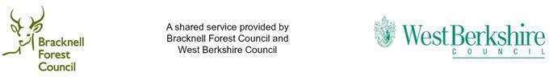

PUBLIC PROTECTION PARTNERSHIP

TACKLING THE HARM FOR THE ILLEGAL SALE OF AGE RESTRICTED PRODUCTS

Policy Context
- Many everyday products sold at retail level can present risks if misused, abused or in some cases such as tobacco present inherent health risk of themselves.
- The illegal sale of age restricted products has a detrimental impact on the health and wellbeing of individuals and on the wider community.
- The impact on the physical and mental health, wellbeing and safety of young people can be significantly affected by the illegal sale of age restricted products.
- The effective control of young people having access to harmful and potentially harmful age restricted products is critical to delivering wider Council objectives and strategies around health and wellbeing (including health inequalities), safer communities and safer streets.
- In delivering this important policy area, the PPS will work closely with key partners including schools, public health teams, Thames Valley Police and others identified in the relevant control strategy.
- We will continue to work with programs and projects being delivered through partner organisations involved in the delivery of trading standards including the National Trading Standards Board and Trading Standards South East.
- It is recognised that online trading is now a significant part of the trading environment for ‘age restricted products’ therefore the approach taken to enforcement will include the monitoring of on-line sales for compliance.
- Illegal activity such as smuggling, counterfeiting and the sale of non-compliant and illegal product can undermine the controls to protect young people from harm, these include the fiscal controls such as duty. For this reason, our enforcement programme will include tackling illegal products.
- It is also recognised that this area of service delivery has strong links to the delivery of the licensing objectives around public safety. the prevention of public nuisance and the protection of children from harm.
Working with Retailers
- The Public Protection Service (PPS) acknowledges the role that responsible retailing plays in ensuring the sale of such products is conducted in a manner which limits that impact and the harmful effects on the safety and health of individuals. To this end the PPS will work with retailers to raise awareness of risk and to improve compliance. This work will be particularly focused around new controls or where emerging concerns at local or national level have been identified.

- The PPS will continue to encourage and support responsible retailing by offering advice and support on how to best achieve compliance with the legislation relating to the sale of age restricted products.
Working with the Community
- The PPS will continue to raise awareness in the wider community of the issues relating to the misuse of age restricted products by young people and to seek the support of the community in driving out illegal sales by encouraging reporting and building local intelligence pictures.

- The PPS recognises the role that the wider community plays in supporting young people to make informed choices. Through targeted product related schemes and initiatives, the service will continue to engage with young people and the education community in order to close the circle between education and regulation putting real lives and impacts at the heart of the implementation of regulation.

- The PPS will continue to support wider council strategic objectives that reduce the physical and mental health impacts of harmful age restricted products as well as the wider societal impacts relating to the safety of communities and individuals.

Links to the Licensing Functions

- The PPS will ensure that work programmes are clearly linked to the delivery of the ‘licensing objectives’ including playing our full part as ‘Responsible authorities’ under the Licensing Act 2003. This will include policy input, reviewing applications, enforcement and where appropriate reviews and legal actions. These will be reported to each Licensing Committee annually.

- The PPS will use powers such as the instigation of licence reviews or temporary closure orders to secure ongoing compliance with the law and to provide a deterrent effect by highlighting the commercial risks of non-compliance.

Enforcement

- The PPS in conducting our enforcement work, will continue to develop and have regard to intelligence, whether from partner agencies or the wider community.

- While acknowledging the national guidance on the conduct of test purchase operations, it is the view of the PPS that wider geographical operations support legitimate businesses and play a significant role in gathering intelligence and assessing overall compliance levels.

- The PPS is of the view that test purchasing used as part of a balanced approach helps maintain a high level of vigilance and provide visible reassurance of our efforts to secure a level playing field.

- Test purchasing programmes will in their development and delivery include product appropriate levels of online test purchasing.

- We believe that our operations should recreate a real-life scenario and young people involved in test purchasing operations will be allowed to conduct the test purchase in a manner which is consistent with real-life.

- In carrying out test purchasing, steps to provide safeguards for both the young person and the trader are taken including having regard to national guidelines in respect of ensuring the safety of young people. Where appropriate we will take legal or other action against traders and individuals in accordance with the PPP’s adopted Enforcement Policy.

- There will be a comprehensive enforcement programme relating smuggled, counterfeit and illegal goods that undermine controls to protect young people from harm.

Review
- The Joint Case Management Unit will keep under review new legal requirements and adjust operating policies and procedures accordingly.

