REPORT OF AN ACCIDENT CAUSING DAMAGE TO A HACKNEY CARRIAGE OR PRIVATE HIRE VEHICLE
Section 50(3) Local Government (Miscellaneous Provisions) Act 1976
If a licensed vehicle has been involved in an accident, the proprietor must report this to us within 72 hours. It is a legal requirement that the proprietor of the vehicle submits this form, not the driver, however the proprietor will require information from the driver of the vehicle at the time in order to complete details of the accident.
Please note: If you knowingly or recklessly make any false statement or omit any material information on this form, you may be prosecuted for an offence and your licence may be revoked. Please also note this report does not remove the responsibility of the driver to report an accident to the Police as required by the Road Traffic Act 1988, nor the requirement for any licence holder to notify the Council of any criminal proceedings arising out of the accident.
Section 1: Organisation Details
Vehicle Proprietor(s)
Address
Email |  | Telephone
Section 2: Vehicle & Driver Details
Hackney or Private Hire
Plate Number |  | Plate Expiry
Registration Number |  | Colour
Make & Model
Driver |  |  | Badge Number
Section 3: Accident Details
Date |  | Time
Location
Weather
Accident Circumstances
Please describe how the accident occurred including details of all vehicles involved
Photos taken at scene? | Yes / No

Section 4: Reporting Details
Reported to police? | Yes / No
Incident Number

Section 5: Vehicle Damage Details
Was the vehicle recovered or driveable following the incident?
Please provide details of the vehicles current location and any Recovery/Storage company.
Accident Sketch
Please mark the areas damaged in the accident on your vehicle in the below diagram: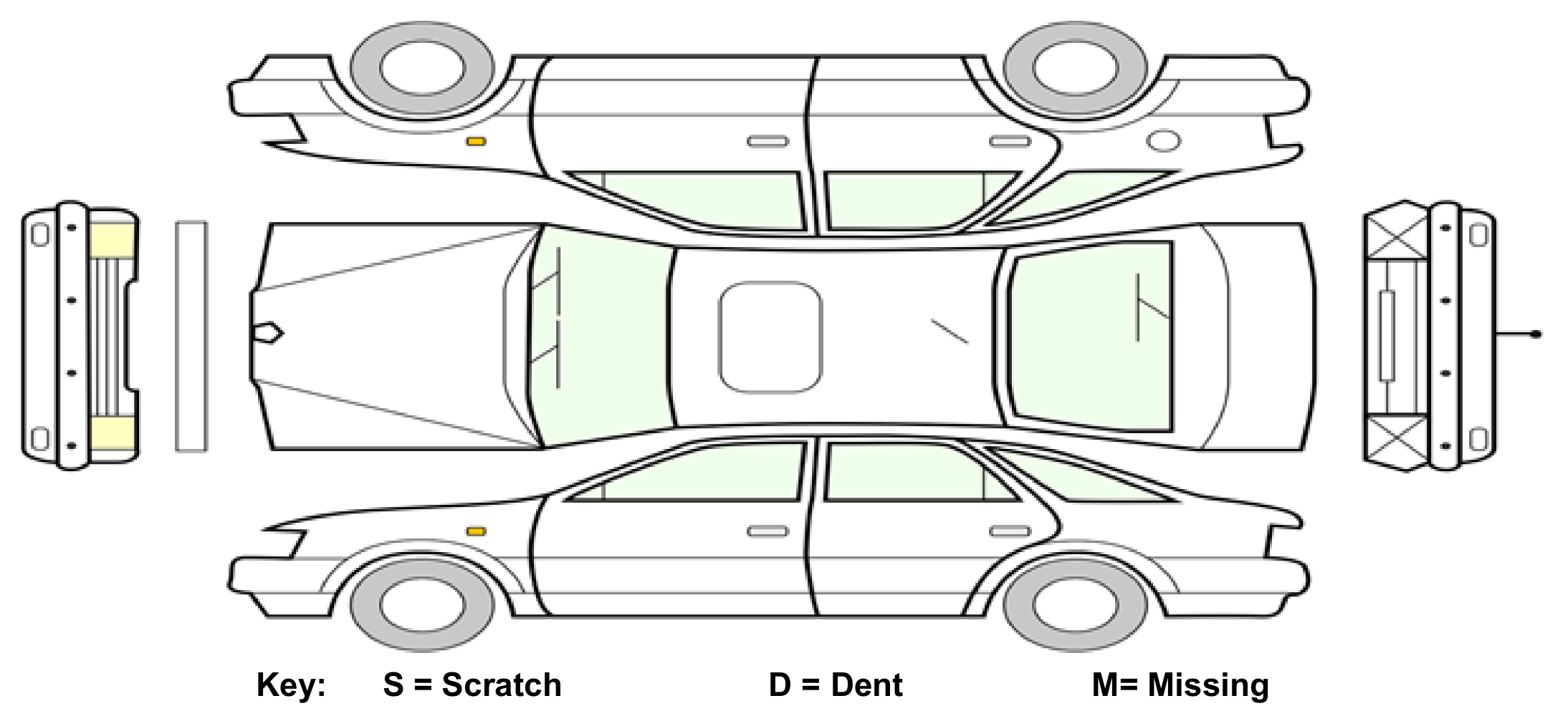

Mileage at time of accident
Damages & Severity
Please describe the damages in each marked area, including its severity:

Section 6: Injury Details
Were you (or the driver if completed by anyone other than the driver) injured? | Yes / No
If yes, please describe injuries sustained and if ability to drive was affected

Time off work? | Yes / No
Medical advice sought? | Yes / No
Were any passengers present in the vehicle at the time of the incident? | Yes / No
Passenger name

Passenger address

Did the passenger(s) appear to be or report any injuries? Please provide details

Was an ambulance called to the scene? | Yes / No
Section 7: Other Vehicle Details
Registration, Make and Model

Other vehicle driver name

Other vehicle driver address

Other vehicle driver contact details

Did the other vehicle contain have any passengers? | Yes / No
Did the other driver, or their passenger(s), appear to be or report any injuries? Please provide details

Section 8: Replacement Vehicle
Has provision been sought for a replacement vehicle? | Yes / No
Replacement vehicle provider
(including telephone)

Replacement Vehicle Registration, Make & Model

Date of commencement:

Declaration:
I believe that the facts stated in this accident report form are true. I understand that proceedings for contempt of court may be brought against anyone who makes, or causes to be made, a false statement in a document verified by a statement of truth without an honest belief in its truth

Signed: |  | Date:

This form should be submitted to the Licensing Team by email to licensing@westberks.gov.uk or licensing@bracknell-forest.gov.uk. An officer will contact you once they have reviewed this form and will arrange for an inspection of the vehicle if required.

