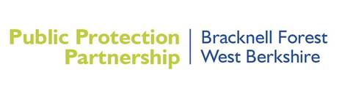

Consultation on the Draft Nuisance Policy

Bracknell Forest and West Berkshire Councils are consulting on the Draft Nuisance Policy. To find more information and take part in the consultation please visit the [West Berkshire Consultation and Engagement Hub](https://www.westberks.gov.uk/consultations) before midnight on Monday, 19 August 2024.

The consultation will go live at 09h00 on the 08th July 2024 and will be open until 23h59 on the 19 August 2024. If you can’t access the survey online please email: [PPPConsultations@westberks.gov.uk](mailto:PPPConsultations@westberks.gov.uk) or contact Moira Fraser on 01635 519045 for a hard copy.

We look forward to hearing your views.

