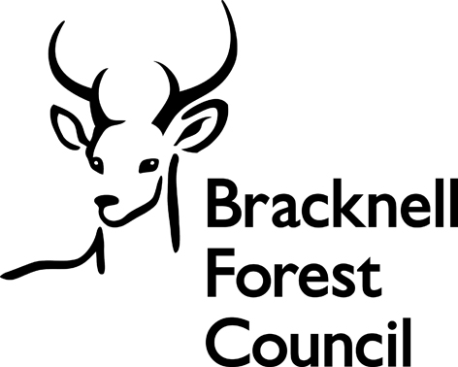
CHANGE OF VEHICLE REGISTRATION APPLICATION

Local Government (Miscellaneous Provisions) Act 1976
Town Police Clauses Act 1847

Type of licence currently held: (Please tick relevant box)
Hackney Carriage |  |  |  |  | Private Hire |  |  |  |  |  | Home to School
If applying for Private Hire, does this vehicle currently have a dispensation?  (Please note this only applies to vehicles only engaged in corporate account work) |  |  |  |  |  |  |  |  |  |  |  |  |  |  | YES/NO
Old Registration |  |  |  |  |  |  |  |  | New Registration
Vehicle Identification Number
(VIN - This is found on the V5 or MOT Certificate)
Surname |  |  |  |  |  |  |  |  |  | Mr / Mrs / Miss / Ms / Other
First names (in full)
Full address |  | Postcode
Email address
Telephone number |  |  |  |  |  |  |  | Mobile number
Date of birth
Name of operator
(if applicable)
Vehicle Details
Vehicle colour |  |  |  |  |  |  | Vehicle make
No. passenger seats |  |  |  |  |  |  | Vehicle model
Engine capacity (cc) |  |  |  |  |  |  | Date of registration

Fees for licences 2024 -2025

Type of Licence | £
Change of registration number | £33.50 + sticker and licence costs (£31)

Payment Information

Payment can be made on-line
- https://publicprotectionpartnership.org.uk/make-a-payment/

Please tick to confirm you have enclosed the following with your application:

A receipt for payment of the fee (non-refundable)
Original current insurance certificate or cover note to confirm new registration
Original V5 document or DVSA documentation to confirm the change of registration
Current Plate, Licence and Windscreen Sticker (and dispensation certificate if applicable)

The completed form and any enclosures should be handed into the Customer Service Centre at Time Square, Market Street, Bracknell, RG12 1JD. Please note only fully completed applications with all the correct fees and enclosures will be accepted. We can only accept original documentation, of which we will make a copy. Faxed copies will NOT be accepted.

We will contact you when your licence is ready for collection. We aim to issue licences within two working days of receipt of the completed application.

An applicant commits an offence if they knowingly or recklessly make a false statement or omit any relevant information and any licence issued may be revoked.

Information provided on application forms will be disclosed to other agencies such as the Police and DVLA where there is a legal requirement to do so, for example in relation to the investigation of a suspected offence. This authority is under a duty to protect the public funds it administers, and to this end may use the information you have provided on this form for the prevention and detection of fraud. It may also share this information with other bodies responsible for auditing and administering public funds for these purposes. For further information, see www.bracknell-forest.gov.uk/nationalfraudinitiative or contact Internal Audit on 01344 352322.

Declaration:
I hereby certify that all statements in this application are correct and true to the best of my knowledge. I have read the guidance supplied, enclosed any required documentation and fees, and agree to abide by the conditions placed on the licence should it be granted.

Signature………………………………………………….

Print Name…………………………………………..

Date signed……………………………………………….

Signature of Operator……………………………………………… (private hire/home to school vehicles only)

Name of firm ……………………………………………………………………………………………………

Ethnic Monitoring

Bracknell Forest Borough Council operates a policy of equal opportunity and fair treatment for all. To assist in monitoring our policy (and for this reason only), applicants are asked to give details of their ethnic origin.

Please state which of the following best describes your ethnic origin:

Black UK
Black African
Black Caribbean
Asian
Indian
Indian UK
Pakistani
Pakistani UK
Bangladeshi
Bangladeshi UK
Chinese
White UK
White European
Irish
If you do not belong to any of these categories please specify

